1.**Introduction**

1.1 **Purpose**:

The purpose of this document is to build a pharmacy management system to manage the medicine category,medicine transaction,customers and suppliers of the pharmacy to ease the pharmacy management.

1.2 **Document Conventions:**

DB Database

ERD Entity Relationship Diagram

1.3 **Intended audience and reading suggestions:**

This project is developed for manage pharmacy system.This project is useful for the pharmacy management team and as well as to the suppliers and customers.This project has been implemented under the guidance of Honourable Unversity Lecturer.

1.4 **Project Scope:**

Pharmacy management system is based on the web application.The system is based on relational database with its pharmacy management functions.All the customers orders ,pharmacy orders and overall transaction of the pharmacy are managed through this user friendly system.

1.5 **References:**

* https://krazytech.com/projects
* Database system concepts by Silberschatz,Korth and Sudarshan

**2 Overall description**

**2.1 Product perspective:**

A pharmacy management database system stores the following information:

* Manage user: It includes user permission such as managers.
* Medicine Details: It includes the name,genre,price and cost,supplier name,quantity,shelf No. of the medicine.
* Customer details: It includes the name ,mobile number,address of the customer.
* Supplier Details: It includes the name ,mobile number,address of the supplier.

2.2 **Product features:**

The major features of pharmacy database system as shown in below ER model: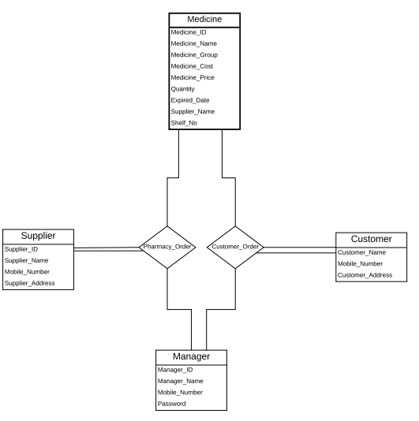

2.3 **User classes and characteristics:**

There are two types of user in pharmacy management system.Manager,Customer.

* Customer:
* View available medicine .
* View the genre of medicine.
* View the medicine price.
* View the supplier name of the medicine.
* Manager:
* Manage user
* Manage medicine details
* Manage customer.
* Manage supplier.

2.4 **Operating Environment:**

* Database: MySQL
* Client/server system
* Operating system: Windows or Linux
* Platform: Web browser

2.5 **Design and implementation constraint:**

1. Design user interface using front-end technologies such as HTML,CSS,Bootstrap,JavaScript and jQuery.

2.Design database(ERD)

3.Implement required functionality using PHP.

2.6 **Assumption and dependencies:**

In this application ,there are a lot of dependencies.To create the pharmacy information,you will need to have the medicine details,customer details and supplier details on the system.Without these the pharmacy information is incomplete.

3 **System features**

**3.1 Functional requirements:**

* Manage user
* Add new manager details.
* View,update and delete manager information
* Manage medicine
* Add medicine details.
* View ,update and delete medicine
* Manage customer
* Add customer details.
* View,update and delete customer
* Manage supplier
* Add supplier details.
* View ,update and delete supplier.

4 **External Interface Requirements**

**4.1 User interfaces:**

Front-end:HTML,CSS,Bootstrap,JavaScript and JQuery.

Back-end:PHP

Tools:XAMPP,Brackets,Notepad++.

4.2 **Hardware Interfaces:**

* Computer
* A web browser which support HTML5,CSS3 & JavaScript.
* Printer

4.3 **Software Interfaces:**

* Operating system: Windows operating system for its best support and user friendliness.
* A modern web browser

4.4 **Communication interfaces:**

This project supports all types of web browsers but should be updated.

5 **Non-functional requirements**

5.1 **Performance Requirements:**

E-R Diagram constitutes a technique for representing the logical structure of a database in a pictorial manner. This analysis is then used to organize data as a relation, normalizing relation and finally obtaining a relation database. Design ERD use online tools such creatly.com, lucidchart.com etc. Normalization is a database design technique which organizes tables in a manner that reduces redundancy and dependency of data. Here we have normalized up to 3NF.

5.2 **Safety Requirements :**

If there is any damages or disk crash, the recovery method restores a recent past copy of the database that was backed up to cloud storage.

5.3 **Security Requirements:**

Security systems need database storage just like many other applications. However, the special requirements of the security market mean that vendors must choose their database partner carefully. Every single page is protected, without login nobody can not view or manage web page, excluding public user interface.

5.4 **Software Quality Attributes:**

**AVAILABILITY**: The available medicine should be show to manager and user in current time. Available customers details,suppliers details also should be show to manager in current time.

**CORRECTNESS**:The medicine details,customer details and supplier details should be correct.

**MAINTAINABILITY**: Manager should maintain the correct medicines,customers and suppliers.

**USABILITY**: The system should satisfy the maximum number of customers and managers.